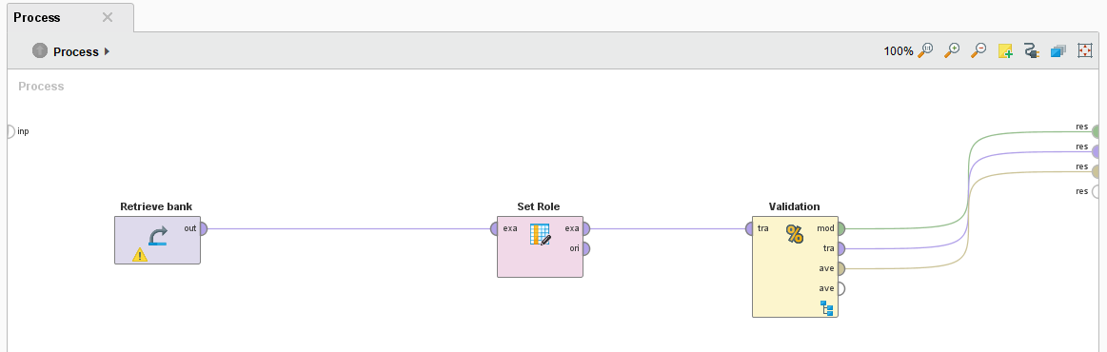

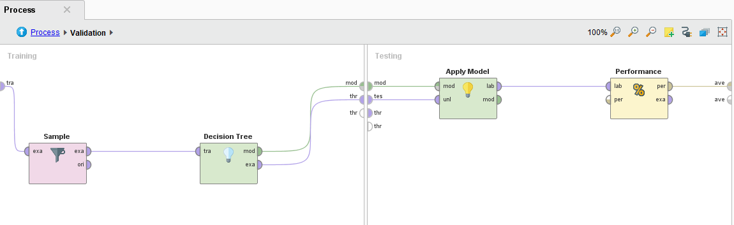

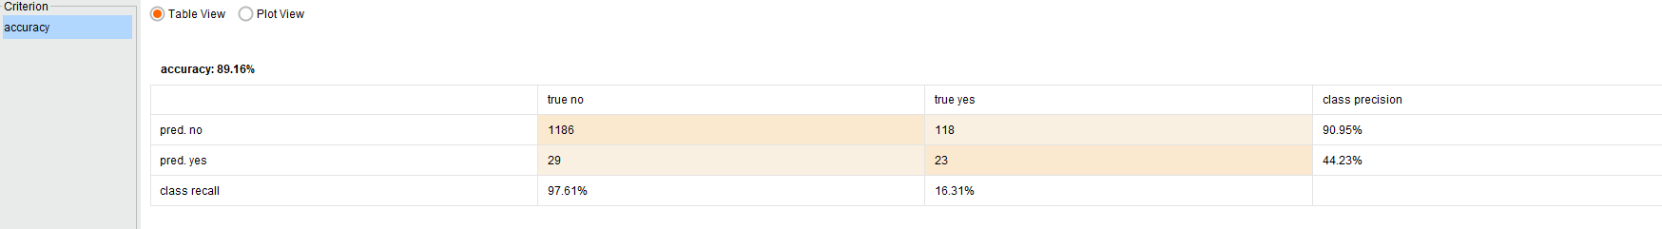

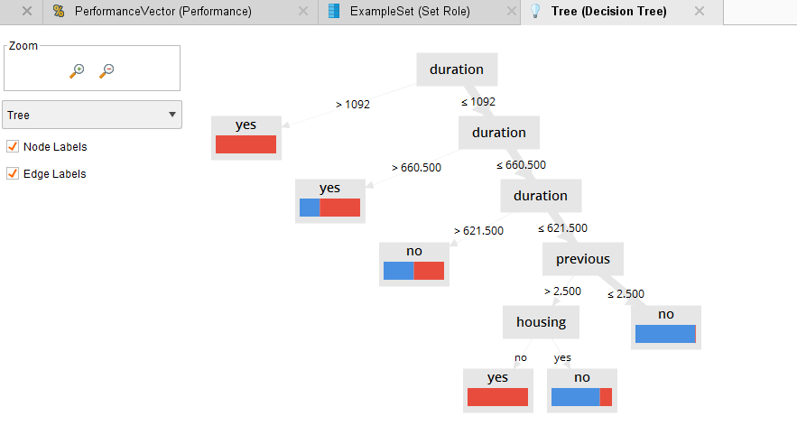

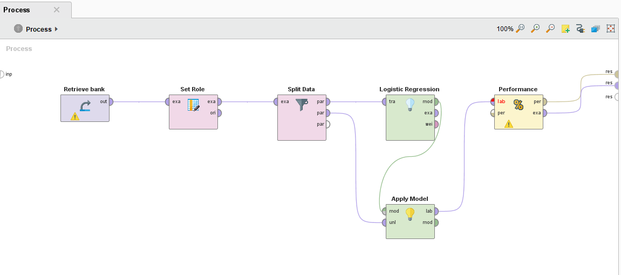

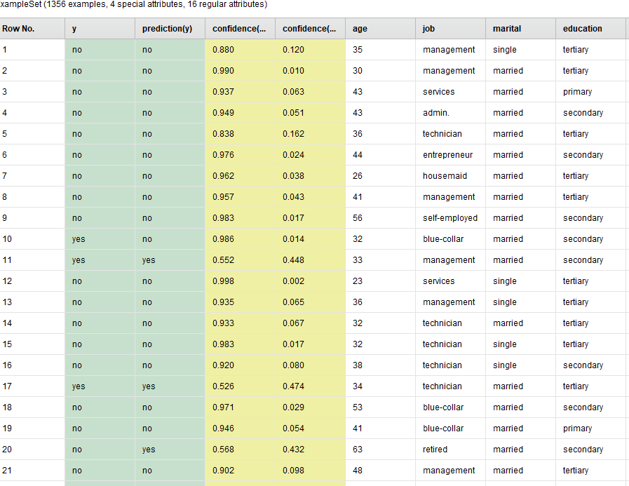

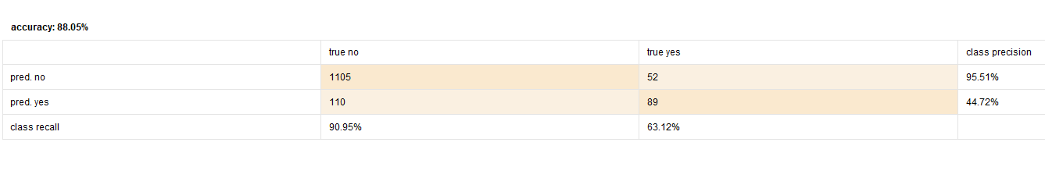

References:

[7] Lili KUANG. Discussion on Apriori algorithm and FP-tree algorithm. Huaibei Coal Industry Teachers College (NATURAL SClENCE EDITION), 2010, 31 (2).